*Cultural Society of India/*

*TSHT*

*Golf Outing*

[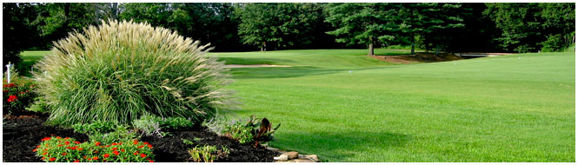](http://www.villageofcambridge.com/)

Golfers

Please provide the names of each golfer on your team(s).

1.________________________________

2.________________________________

3.________________________________

4. _______________________________

Please feel free to contact Dr. Krishna at 812.386.6776 or

pediatricscenter@gmail.com

with any questions.

**For more information about the**

**golf course, visit www.quailcrossing.com**

**Quail Crossing Golf Club**

5QuailCrossingDrive   
Boonville, IN 47601  
Phone: 812-897-1247  
  
**Sunday, September 11, 2016**

**Registration/Lunch**

12:00 p.m.-12:45 p.m.

Shotgun Start at

12:45 p.m.

100 Golfers – 25 Foursomes

Enjoy a complete program of special events, 18 holes of golf (including cart), Lunch, Indian Dinner and door prizes. All for just $500 per foursome

**Contact Information**

**Dr. Prajapati 270-685-5540**

**Dr. V. Soni 270-389-0504**

**Dr. Anadkat 618-263-4376**

**Dr. Jani 618-263-4229**

**Dr. M. Shah 270-926-4691**

**Dr. M.S. Krishna 8123866776**

**Mr. K.C. Jain 812-476-7955**

**Mr. D.GOYAL 270-686-0050**

**Dr.Sumir Bhateja 812-858-3736**

**September 11, 2016**

**Quail Crossing Golf Club**

**Boonville, IN**



This year’s event will be held Sunday, September 11, 2016 at the well-manicured Quail Crossing Golf Club in Boonville, Indiana.

This special event is hosted by the Cultural Society of India, a not-for-profit philanthropic organization, promoting cultural heritage of India, provide a forum for cultural activities, and participate in the educational and cultural enrichment of the Tri-State Community.

The cost for this event is $500 per foursome. This price includes entry into all events, 18 holes of golf with cart, Lunch and an authentic Indian Dinner.

To help us properly plan for this event, please pre-register by filling out the form in this brochure.

Registration/ Lunch at 12:00p.m

Shotgun Start at 12:45pm

*All Sponsors will be eligible to receive a charitable income tax deduction.*

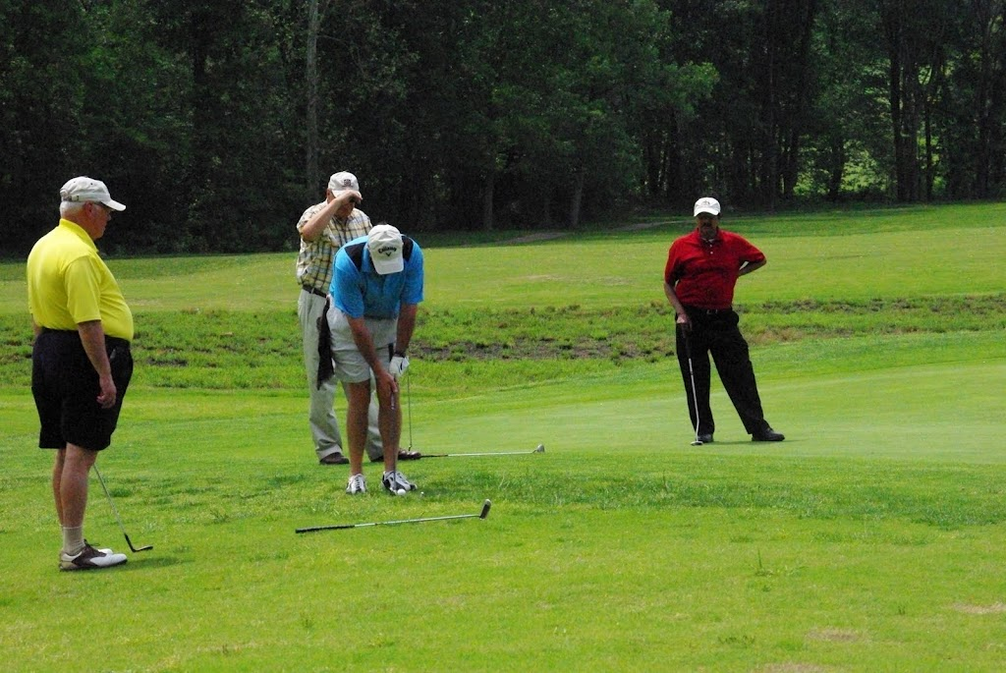

**______________________________**

**_______________________________**

**_______________________________**

Address:

Contact Name:

Company Name:

**_______________________________**

**______________________________**

**Team (Four)**

**Individual**

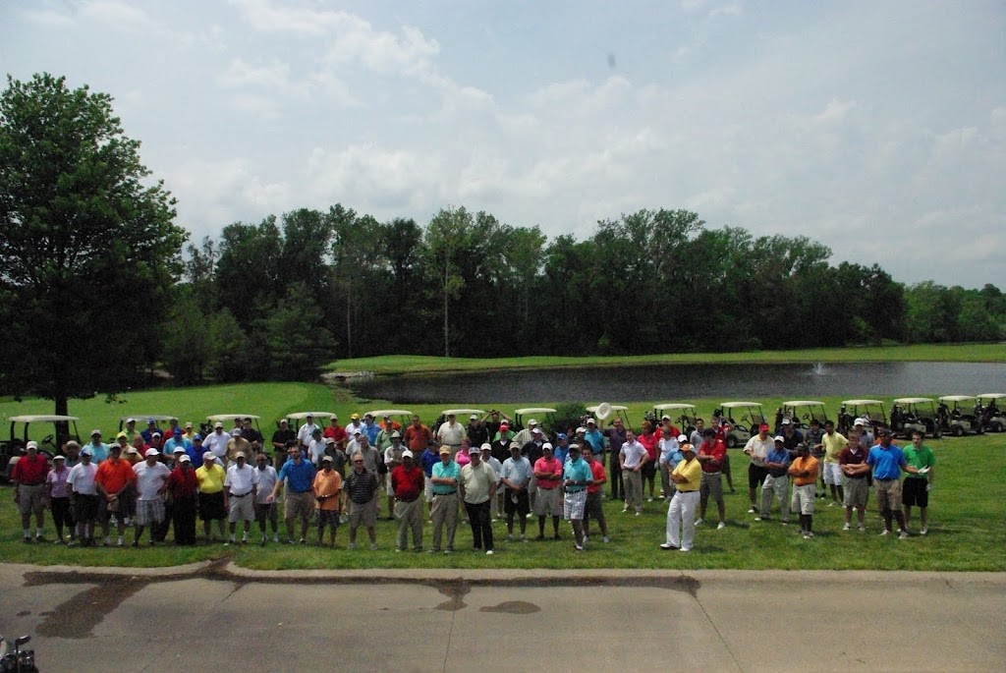

**Team Sponsor ($500)**

18 holes of golf with cart

Lunch, drinks and authentic Indian Dinner

**Individual Player ($150)**

**The Gold Sponsor ($2,500)**

Co-Naming of Event (Joint event sponsor)

Logo prominently displayed in event program

Recognition in event program

Signage at a tee box

Name on Sponsor Banner

Free entry for one foursome

**The Silver Sponsor ($1,000)**

Recognition in event program

Signage at a tee box

Name on Sponsor Banner

Free entry for one foursome

**The Bronze Sponsor ($500)**

Recognition in event program

Signage at a tee box

Name on Sponsor Banner

**Hole Sponsorships ($250)**

Signage at a tee box

**Cart Sponsorships ($100)**

Signage on a cart

**Vendor Sponsors**

Please make *all* checks payable to the *Cultural Society of India[CSI]orTSHT.*

*Please return form to:*

M.S. Krishna

312 Third Avenue

Princeton, IN 47670

[pediatricscenter@gmail.com](mailto:pediatricscenter@gmail.com)

Tel: 812-386-6776

**Vendor Sponsor**

**Hole Sponsor**

**Gold Sponsor**

**Sponsorship Opportunities**

**Bronze Sponsor**

**Cart Sponsor**

**Silver Sponsor**

**Join Us!**

